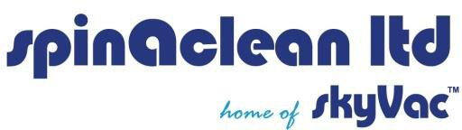

Agreement to Hire Equipment

I understand that it is my responsibility to pick up the equipment and to return it to the same location at the end of my hire period unless otherwise agreed by both parties. I agree to return the equipment to Spinaclean Ltd in the same condition it was in on the day I hired it.

I understand it is my responsibility to use the equipment correctly and to order the correct equipment for the intended use.

I understand that it is my responsibility to inform Spinaclean Ltd of any damages from transit within 24 hours of receipt of equipment (This excludes weekends and allows 24 hours to the next working day). If notice has not been given within 24 hours, I accept that the damage is my responsibility.

I understand that the deposit paid covers any damages made to the equipment whilst in my possession. I accept that there is a standard £30.00 cleaning charge for equipment returned in a used state, a standard £45.00 labour charge for any repairs made to damaged equipment and a variable charge to replace broken or damaged parts. I understand the SkyVac poles cannot be used in thunderstorms or touch overhead power cables.

I understand that if the equipment requires delivery/collection, a maximum of two failed attempts will be accepted. In the absence of courier liability, if further attempts are required these charges will be forwarded on to me, the customer.

……………………………………………..

Signature

……………………………………………..

Print Name

………………………………………………

Date